**What is a firebug?**

Firebug was a [free and open-source](https://en.wikipedia.org/wiki/Free_and_open-source)[web browser](https://en.wikipedia.org/wiki/Web_browser) extension for [Mozilla Firefox](https://en.wikipedia.org/wiki/Firefox) that facilitated the live [debugging](https://en.wikipedia.org/wiki/Debugging), editing, and monitoring of any website's [CSS](https://en.wikipedia.org/wiki/Cascading_Style_Sheets), [HTML](https://en.wikipedia.org/wiki/HTML), [DOM](https://en.wikipedia.org/wiki/Document_Object_Model), [XHR](https://en.wikipedia.org/wiki/XMLHttpRequest), and [JavaScript](https://en.wikipedia.org/wiki/JavaScript)

**How to configure firebug with the Firefox browser?**

1. Go to Google and search for “Firebug Download for Firefox

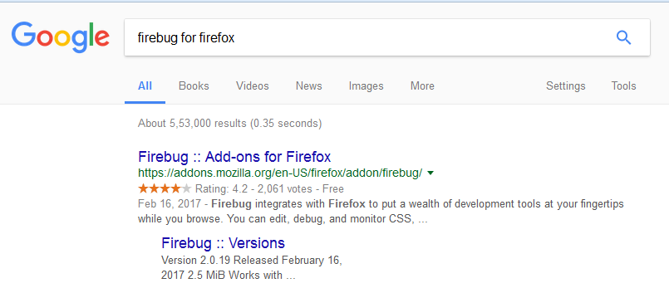

2. Download and install it

3. Once you install, restart the browser and launch it again.

4.You will be seeing an icon on the top right side with an ant icon

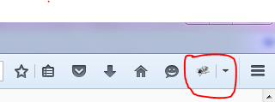

5.Navigate to any application

6.Press ctrl+F12

7.You should see an option firepath

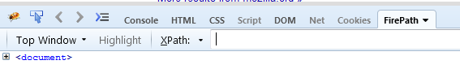

8.Click on the mouse pointer

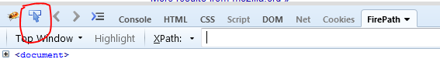

9.Now try to identify any one of the object. it should identify with blue layout shown as below

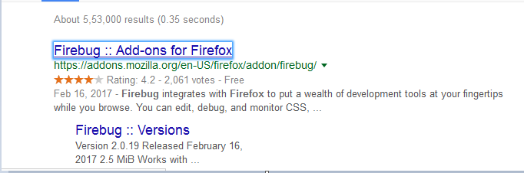

10.Now see under the fire path option it should prefilled with the x-path of the test object

